The main page :

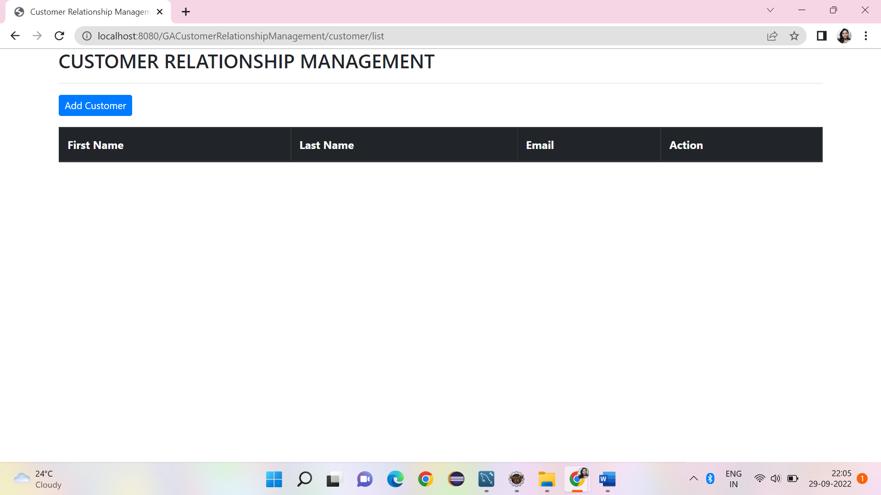

Add customer page which allows to add customer details:

Customer added successfully and shown from customer List page

Added multiple customers

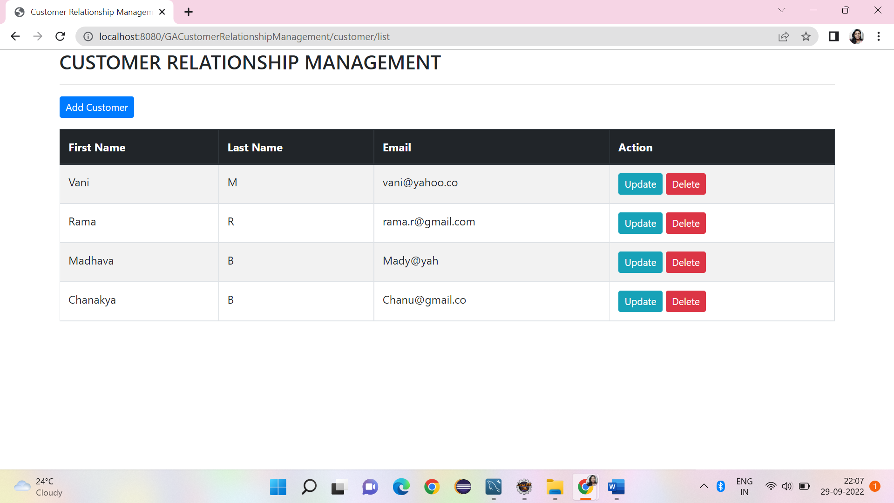

Update operation performed on customer , existing customer details displayed retrieving from database allows to modify

Record is modified successfully as given from Update page

Delete operation performed

Delete of record is successful, remaining customers list displayed

Back to List working good

Taking control back to main page without performing any operations

CRUD operations performed from the database and same is reflecting from the Select query of MySQL

